Experiment – 16
High Level Programming Extensions – Procedures

SMOHIT ARMAN SWAIN
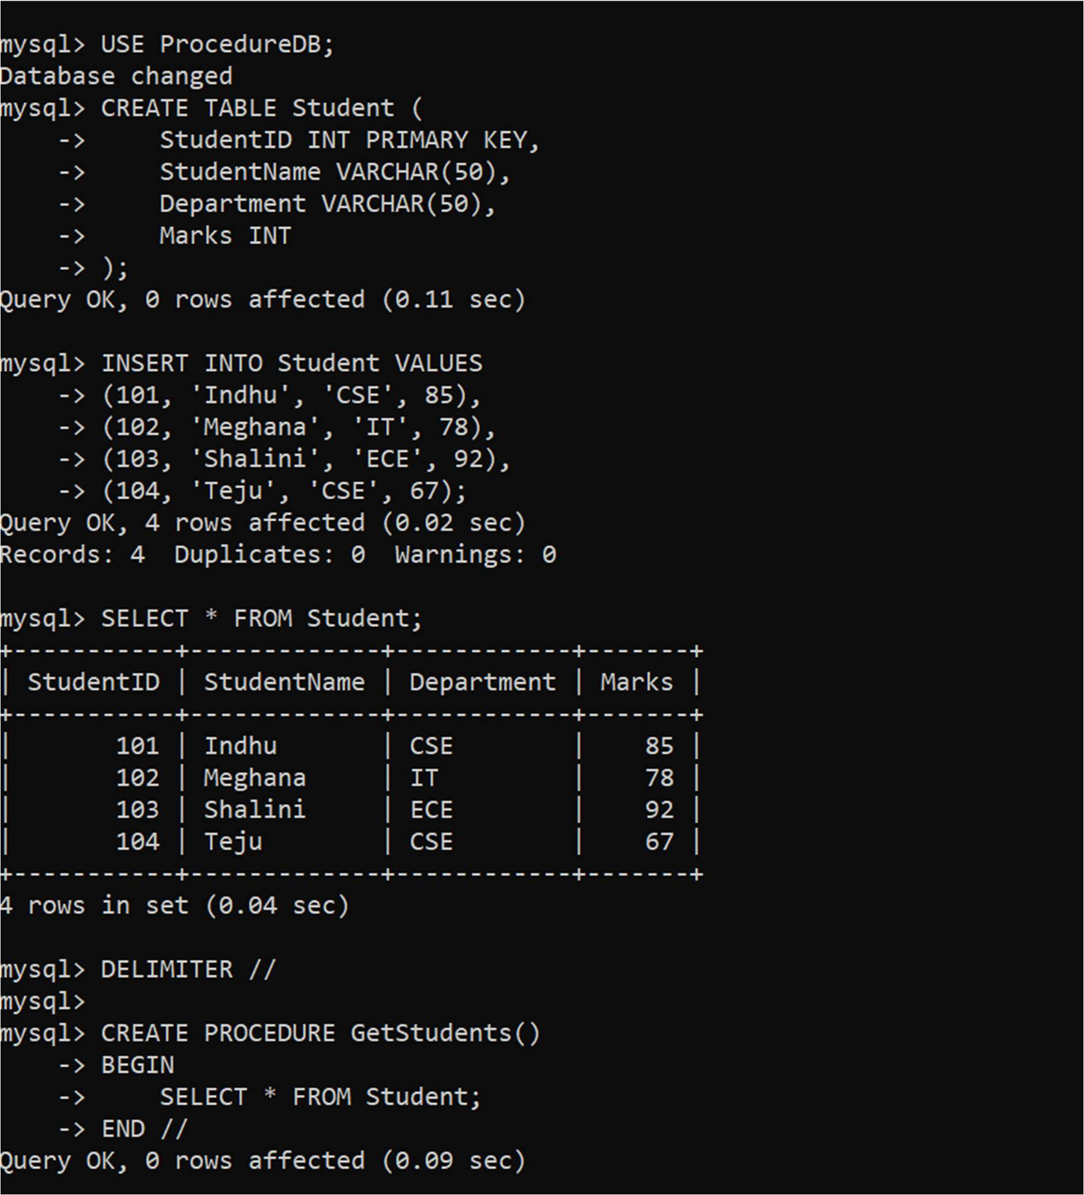
192572092
CS0504-DBMS
